Game Design Document

KOBRA - Tower Defence Mayhem

Kobra Logo

#### Created by Callam Bennett

#### Student name

|  |
| --- |
| Callam Bennett |

#### Student Card number

|  |
| --- |
| 10554518 |

#### Game Name

|  |
| --- |
| KOBRA - Tower Defence Mayhem |

#### Trello link

|  |
| --- |
| https://trello.com/b/lu5grspS/aint152-games-workshop |

#### GIT repository link

|  |
| --- |
| https://github.com/CallamBennett412/AINT152-KOBRA-Tower-Defence-Mayhem |

#### Itch.io link

|  |
| --- |
| https://graviteegames.itch.io/kobratdm |

#### Youtube playthrough link

|  |
| --- |
| <https://www.youtube.com/channel/UCNdgA7nJO6IriBo38EMxOeA> - To be uploaded |

# Game Story

#### Game backstory

|  |
| --- |
| Chief Petty Officer Archibald Kobra, leader of the elite Kobra task force, has been sent to the Hyperion System on Asca V to dispatch and destroy a rogue insurgent droid base. His objective… to destroy all hostiles, overload the reactor and escape Asca V before the droid base has been destroyed.  However, like most black op campaigns there are always complications… as Kobra succeeds in his mission to overload the reactor the base goes dark, all of the power is lost, this means that he cannot overload the reactor... Kobra’s new objective is to discover why the power went out, however in the darkness something more deadly and ominous than rogue droids lurk… It seems as if the base was housing something far more… deadly... |

#### 

## Character 1

#### Character name

|  |
| --- |
| Archibald Kobra |

#### Appearance

|  |
| --- |
| * Orange Armored Neo Mech suit * Orange/blue house colour scheme * The house colour scheme is used to help the player observe where the player is with ease * Handles a modified Korbra MX.III Laser Rifle as a default weapon |

#### Character backstory

|  |
| --- |
| The majority of Kobra’s backstory is marked out with black ink, no one truly knows this man, but the members of the Alliance know him as a hero. What people *do* know of this mysterious soldier is that he started out as a special forces space cadet in the ‘Alliance Terra Command’, building himself up as marine. A few years before ‘Operation Mech’, an individual with the name of ‘Kobra’ led a small group of cadets to exterminate all of Asca IV’s insurgent leaders, resulting in the planet’s implosion. Asca IV is no longer habitable. It is rumoured that Kobra died on Asca IV in the Terra civil war.  Regardless of the rumours, ‘Kobra’ went on to lead a team through more black op missions throughout the coming years. His kill count became the highest in Alliance history, however with each operation one member of his team was extinguished until he was the last man standing. Kobra now has little emotion, acting more and more like a cyborg than human. His cold and callous nature occured after he and his team glassed the planet Perros, killing over a billion people on the mining system; both innocent *and* not. |

#### Stereotypes

|  |
| --- |
| * Armour and weapons are based on ‘Metroid’ * His personality and character is heavily based upon ‘Master Chief’ from the Halo series so that he is a silent yet deadly protagonist stereotype that everyone respects, however my character shows more of a sinister, antagonistic streak where he will do anything to complete the mission, even if it means casualties. * Lack of dialogue aids the idea of a silent protagonistic figure * Typical super soldier that can destroy an army single handedly * Extremely intelligent and is specialized in all aspects of field work (explosives, weapons, vehicles, and flying) |

## 

## 

## Character 2

#### Character name

|  |
| --- |
| Insurgent Rogue Droid |

#### Appearance

|  |
| --- |
| Now Updated to this → |

#### Character backstory

|  |
| --- |
| Mechanical brainless machines that are programmed and created on the ‘Asca V’ colony by an unknown company before its abandonment. Members of the ‘Xhan Insurgency’ came to ‘Asca V’ and started creating the droids to bolster their army.  However while the droids are now under the control and construction of Xhan, all of the insurgents are never seen when Kobra arrives…  The Droids are based upon an ancient alien design called the ‘Bectas’ and they are the forefront of mechanical warfare however, the droids were ordered to shut down after the Terra Civil war ended. They have not seen operation until Xhan. |

#### Stereotypes

|  |
| --- |
| They fit the stereotype of weaker, less challenging enemies in games, however when they swarm together to make larger, more threatening group, they become a problem.  Based on the droids from ‘Star Wars’, which are portrayed in an almost comedic way, fire red energy laser rifles like most enemies in games. The colour red symbolises and connotes danger and violence, therefore enables players and audiences to recognise the bad from the good. |

## 

## 

## Character 3

#### Character name

|  |
| --- |
| Insurrectionist Leader Aka. Gordon Kobra (Also the same sprite as the Kobra Marines under Archibald’s control) |

#### Appearance

|  |
| --- |
| * Orange Armored mech suit outdated model compared to Archibald Kobra’s Neo Suit. * Orange/blue house colour scheme * Custom addons for the suit, using whatever he can salvage. |

#### Character backstory

|  |
| --- |
| ‘Kobra’ was a title given to the most elite of soldiers in the ‘Alliance Terra Army’, however the first individual to hold the title was known as ‘Gordon Kobra’. He led a small group of soldiers in an attack against insurrectionists on ‘Asca IV’ resulting in the death of their leaders. He then became renowned as the first Kobra. He sought out the betterment of humanity but when he was ordered to destroy ‘Asca IV’, he refused and instead, aided those he once fought against. On the other hand, the Alliance found a way to implode the planet which, in turn killed all those who still remained. It is thought that the first Kobra perished in that particular incident.  Gordon found a way off of Asca before the planet mass killing, with a small group of rebels becoming the new leaders of the Xhan Insurgency. A few years after Gordon came across Asca V, he decided to use the droid facility to bait out the man who now tarnishes his name. |

#### Stereotypes

|  |
| --- |
| Gordon is not your stereotypical antagonist, due to the fact that he is a morally admirable guy. He has rather strong values and like most stereotypical hero-esque characters, he wishes for peace and to save all of those worth saving. He, like a typical insurrectionist who hates corrupt governments, has a strong hatred for the Alliance due to the fact that he knows them as an evil corporation after murdering billions of innocents and using his name to do it. |

## Character 4

#### Character name

|  |
| --- |
| Terra Mark.X CPMS (Combat purpose Mechanical suit) Nicknamed: Mantis |

#### Appearance

|  |
| --- |
|  |

#### Character backstory

|  |
| --- |
| This was built during the ‘Terra Civil war’ as a means to kill and dispatch enemies with ease. While it is slow and clunky to move, it boasts massive fire power with shooting laser cannons that fire at rapid speed. Mantis was pivotal to large Operations and soon became Kobra’s favorite means of transport. Not only can the Mantis be manned by soldiers it also contains an AI, allowing the mech to fire at targeted enemies. Unknowingly, Xhan have found a way to utilize the AI, converting the Mantis to their side.  The Mantis can prove problematic for those having to face it... |

#### Stereotypes

|  |
| --- |
| * Mech Suit is based on the suit from the film ‘District 9’ * Heavy ordnance is for the player to use when needed * Extremely tough armour * Plentiful amounts of fire power * Slow, sluggish and heavy movement * The cockpit and the rear are extremely vulnerable areas when shot at |

# 

# Visual style

Using other game images, describe the visual style of your game

|  |
| --- |
| My Game art Style^^ - 16/32 bit pixel art and game environment. Wanted to mix the two in order to make the game have simple art work but also be able to make certain things more detailed. For example I had the idea to make the Environment and levels 32 bit so I can add various different objects and details to the game.  Inspired game designs: |

# 

# Sound design

Details about the style of sound used in your game (music style, thematic treatment, FX, menu music)

|  |
| --- |
| Kobra will have a old school catchy and cheesy typical sci-fi shooter style music similar to that of space invaders or galaga. The FX will be that of laser sounds, energy rumbling and ambient sci-fi sounds (such as electricity tesla’s, machines, reactors and batteries).  However Kobra will suddenly take a dark turn when all the lights go off and the theme of the game changes quite rapidly. Suddenly the music goes from being a classic upbeat sci-fi theme to a dark gritty horror. The music has sci-fi elements such as beeping and alarms but the rumbling of machines becomes more sinister and deeper. Some of this section will also have silent ambience in order to build up tension and scare. |

# Menu System

#### Menu flowchart

|  |
| --- |
|  |

## Menu Screens

#### Main menu diagram

|  |
| --- |
|  |

#### Main menu description

|  |
| --- |
| Simple menu design that shows three options on the screen. Start will close the menu and take the player to the games first level. Controls will open a visual overlay showing a keyboard/mobile/controller (depending on format) with all the control mappings for the user to see. The user will then be able to change the controls to fit their own personal standard, making it easier for them to play the game. Pressing back will take the player back to the menu screen incase they need to do anything else via the menu, and when the player is done and satisfied they can either press Start OR select Quit game, which as the name suggests will close the game. |

#### Game Over screen diagram

|  |
| --- |
|  |

#### Game Over description

|  |
| --- |
| When the player dies they will see the game screen change with a game over overlay appearing over the game world. Upon the game over appearing the player will then gain access to 2 options in order to continue. If the player picks the “Restart” option then they will go back and play the game from the start where they can continue on with the game. Or they can choose to Quit which will result in closing the application. |

#### Game screen diagram

|  |
| --- |
|  |

#### Game Screen description

|  |
| --- |
| Upon entering the game you will be met with a tile based game world. To the top right there will be an enemy spawn point that will be animated of some kind, maybe a ship or some form of droid creation sprite. The tiles will change colour when you hover over them so the player knows what tile the cursor is on.  As for the UI I have gone for something very simple yet offers the most feedback to the player. On the left there is the tower selection where the player can click the tower they wish to use and then place it into the game world. Below the Towers I conveniently placed the cash system where the player can see how much money they have in order to buy the towers, there prices are listed under their icons. Under this I have a button that will immediately take the player back to the main menu if they wish to exit the game and stop playing.  At the top of the screen in big lettering it has the wave count, this will tell the player how much progression they have made whilst playing. Next to this is the health bar system where the player loses lives for each enemy that gets into the ship.  On the left of the screen you can see the Next Wave button that progresses the wave round after an intermission. During waves the player will be able to place towers before clicking the button to start the game again. This wave button will vanish after being pressed until the wave has ended. |

# 

# Game Elements

## Player Character

#### 

|  |  |
| --- | --- |
| Character name | Graphics |
| Towers |  |

#### 

|  |  |  |
| --- | --- | --- |
| Property | Description | Type |
| * Movement * Animations * Radius Detection | Towers will turn around targeting enemies on the map.  Player will shoot using the fire button, the gun will depend on which gun the player is holding which the player will be able to swap out at any point.  Animations of the player will occur when the tower is shooting.  Radius Detection being used will show a visual cue such as a circle | Player placed tower |

|  |  |
| --- | --- |
| Sound name | Description (how does the sound interact with the game) |
| * Footsteps * Shooting * Reloading * Abilities | When Player moves it will create a heavy footed sound of a metallic mesh suit hitting a hard surface, this will tell the player that the character is moving.  When the player shoots his gun it will output a laser firing sound, rapid laser sounds for the Laser rifle, a long steady sound for the beam rifle, and a short shotgun sound for the scattergun, this will tell the player that they are shooting.  When the player reloads his gun it will output a short 3 second sound and when the sound has ended, it will tell the player that the gun is ready to fire again.  When the player uses an ability, the sound of a power up will be outputted to tell the player that the ability has been cast. |

## Enemies

|  |  |
| --- | --- |
| Enemy name | Graphics |
| Rogue Insurrectionist Droids |  |

#### 

|  |  |  |
| --- | --- | --- |
| Property | Description | Type |
| * Movement * Animations | Droids will move towards the players base (in the game it will be a ship). Using code and scripting I will have the droids recalculate the route in which they will follow every time the wave starts so they can adapt to placed towers and make there way to the ship.  The droids will have movement animations for when they move. | Enemy |

|  |  |
| --- | --- |
| Sound name | Description (how does the sound interact with the game) |
| * Footsteps * Death | The droids will have clanking metal footsteps, which the player will hear if they are moving.  Death of the droids will result in a malfunctioning sound and a mini short circuit explosion. |

## Blocks

|  |  |
| --- | --- |
| Block name | Graphics |
| Floor tiles: |  |

#### 

|  |  |  |
| --- | --- | --- |
| Property | Description | Type |
| * AStar Pathfinding * Parents and Childs * Numbers to calculate the shortest path from A to B | These tiles will be generated through the use of an array and a text document so that I can easily make levels.  These tiles are very important to the structure of the game and how the game plays because through the use of scripting these tiles will calculate the shortest path from point A to point B. This is a common concept in tile based top down games and it known as AStar pathfinding. | Floor_Tile |

|  |  |
| --- | --- |
| Sound name | Description (how does the sound interact with the game) |
| * Crunching noises | Because the tiles are meant to be similar to sand and stone, when the characters walk on these tiles it will emit a noise similar to sand and rock. This is a more immersive and realistic implementation than just using normal footsteps |

## Collectibles - My game will not be implementing Collectibles as per with the genre. However, I have still made some sprites just incase I do come up with some form of implementation with them.

|  |  |
| --- | --- |
| Collectible name | Graphics |
| Ammo crate  Weapon  Medkit | < In the end I decided to not use these as |

# Level plan

Sound design

|  |
| --- |
| First few levels of the game: Uplifting techno sci-fi music with sci-fi ambient noises such a lasers, electrical discharges, humming of reactors and other machinery sounds. All of these sounds will be made to sound adrenaline pumping and action packed. |

## Key

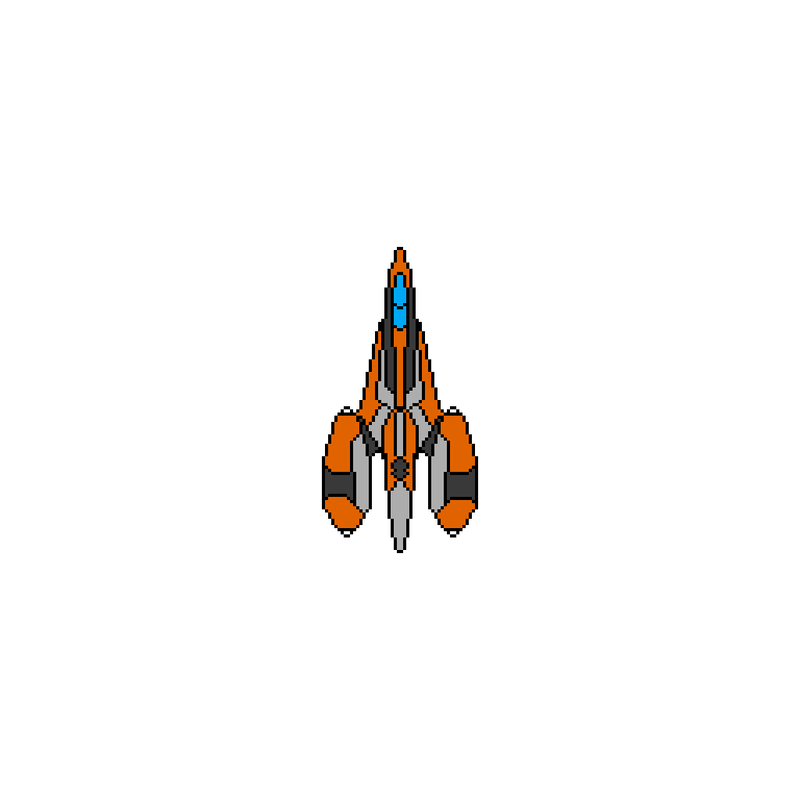

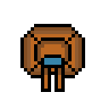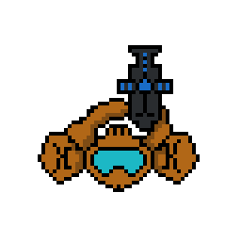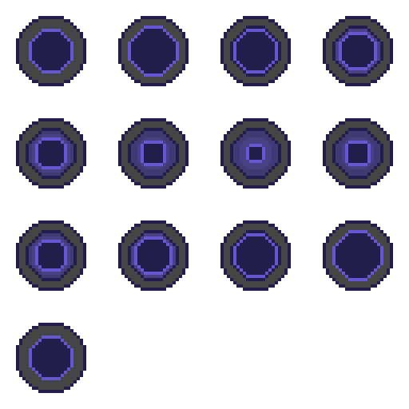

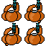

**Ship Towers Droid Spawner**

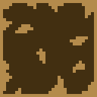Tiles Health bar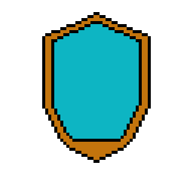

## Level Diagrams

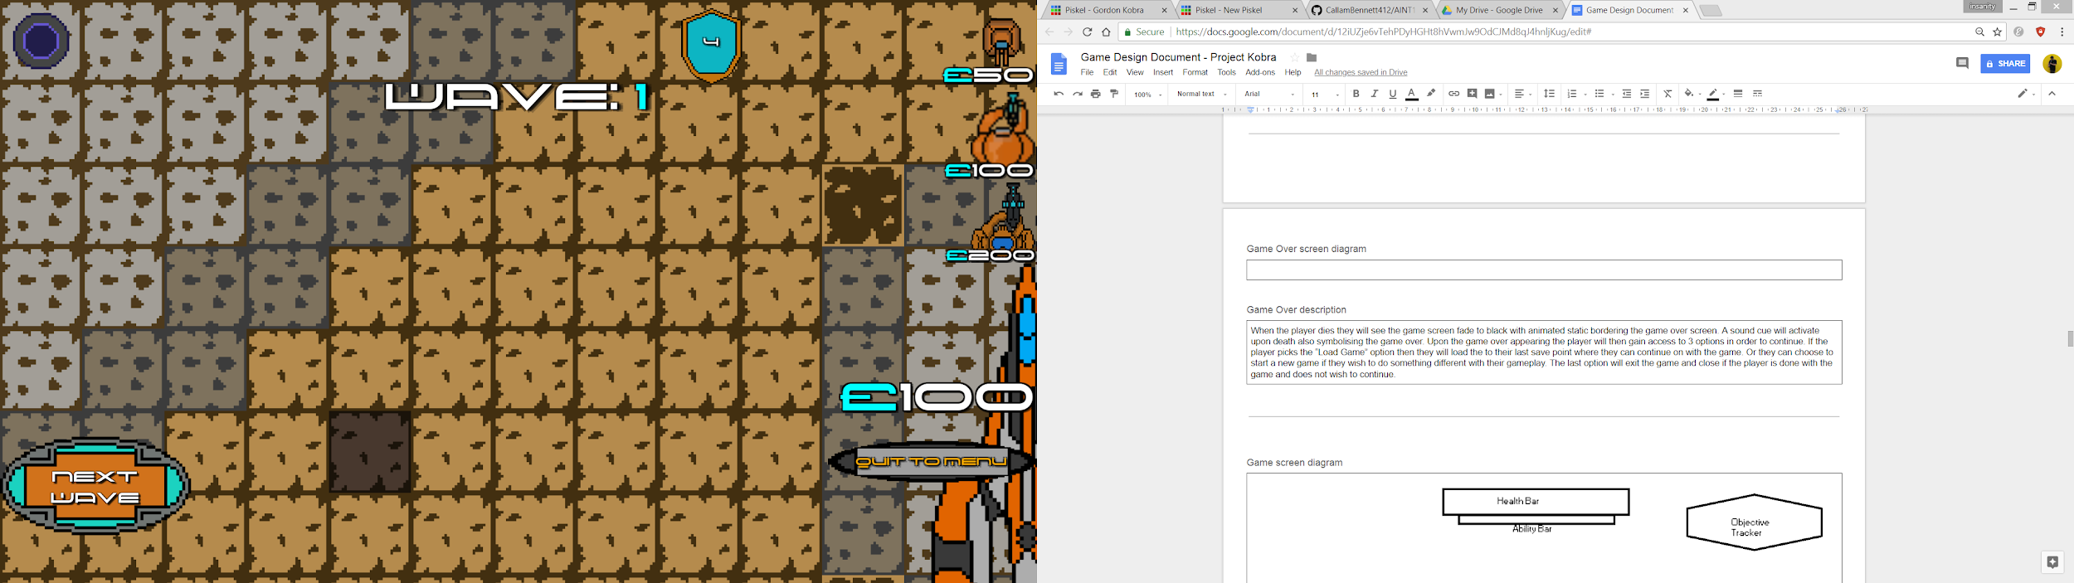

# Game Breakdown

#### Space

|  |
| --- |
| * Stages with points A to B * Can place towers on any tiles * AI adapts to how you play |

#### Rules

|  |
| --- |
| * Complete Objectives * Kill Droids * Don’t die * High scoring style of game |

#### Goal

|  |
| --- |
| * To complete each objective and goal of the game as they come * To avoid Ship being destroyed * Get to as high a wave as possible |

#### Game Elements

|  |
| --- |
| * Shooting droids using towers * Dialogue * Objectives * Different Towers * Custom sounds * Custom music |

#### Mechanics

|  |
| --- |
| * Towers do different things * Top down view * Top down movement style for enemies * Tiled movement so enemies follow set paths when the code is run (this changes each wave) * Object Collision (Such as towers, enemies and the bullets) * Sound effects * Health for enemies * High score system from how high you can get up to |

#### In game controls

|  |
| --- |
| W - Move up  A - Move Left  S - Move down  D - Move right  Left Click - Select  Mouse cursor - Moves in that direction |

# Game Systems

Document any game systems included.

Examples:

* Survival (Player survives sustained attack)
* Dialogue (other characters talk to the player in popup windows)
* Tower selection
* Enemy attributes (e.g. Health)

Dialogue

Dialogue will be implemented into the game in order to help the player progress, but also to give the player more of a foundation for the story and a connection to the character that they are playing as. The Dialogue in the game will appear in the lower portion of the screen when a dialogue scene is activated.

Example of Dialogue in game:

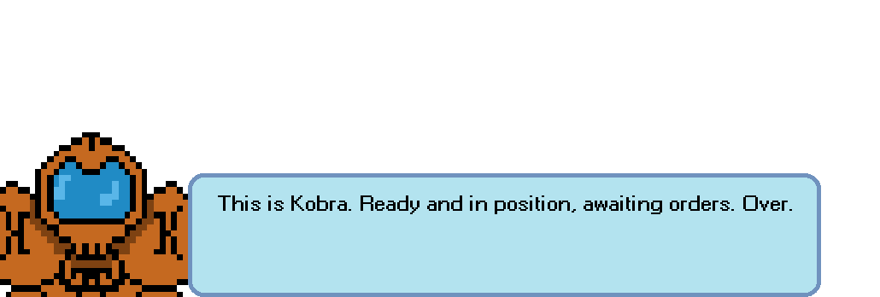

Player’s Tower Attributes

I want towers to have a health bar that will decrease upon being shot, but can also be replenished via the use of Med Kits or repair kits found killing enemies on the levels. If the towers health reaches 0 then the tower will turn to rubble until being revived again for money or sold.

Vehicles - This was supposed to be implemented as an air strike or help for the player ability

The game will also be featuring various differing vehicles(power ups) that the player can use in order to progress through that particular level. Vehicles have varying elements and actions. This means that each vehicle will aid the player in different ways. For example the ship will fly over the map and drop bombs killing all enemies and ending the wave.

# Press Kit

#### Store icon/Logo

|  |
| --- |
|  |

#### Core features

|  |
| --- |
| Tower defense game with a story element in which the player can progress through the levels and play the game unlocking new things along the way. The game will be heavily story driven and hopes to have voice acting, if not then all dialogue will be implemented via text boxes. |

#### Screenshots

|  |
| --- |
|  |

#### Rating

|  |
| --- |
|  |

## Similar games

#### Game name

|  |
| --- |
| Bloons Tower Defence Series |

#### Game link

|  |
| --- |
| https://ninjakiwi.com/Games/Tower-Defense/Play/Bloons-Tower-Defense-5.html#.WwWp2e6UtEY |

#### Game name

|  |
| --- |
| Kingdom Rush |

#### Game link

|  |
| --- |
| http://kingdomrush.com/play/ |

#### Game name

|  |
| --- |
| Psychon 2 |

#### Game link

|  |
| --- |
| https://benjames171.itch.io/psychon-2 |

## Youtube review channels

#### Channel name

|  |
| --- |
| TheAngryBadger |

#### Channel link

|  |
| --- |
| https://www.youtube.com/channel/UCNdgA7nJO6IriBo38EMxOeA/videos |